AI ASS 20.5
Name:B.Sanjana
H.T.NO:2303A52306
Batch:43

#Task1
Prompt:
Generate a Python user registration program and improve it by securely storing passwords using hashing instead of plain text.
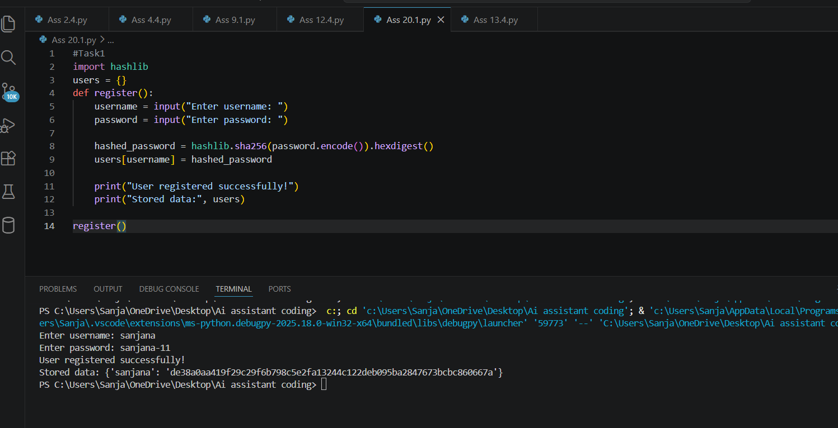
Observation:
The vulnerability of plain-text password storage was identified and fixed by applying SHA-256 hashing.
This ensures secure password storage and protects user credentials from unauthorized access.

#Task2:
Prompt:
Generate a Python script to connect to an external API.
Check whether API keys are hardcoded in the code.
Refactor it using environment variables for secure secret management.
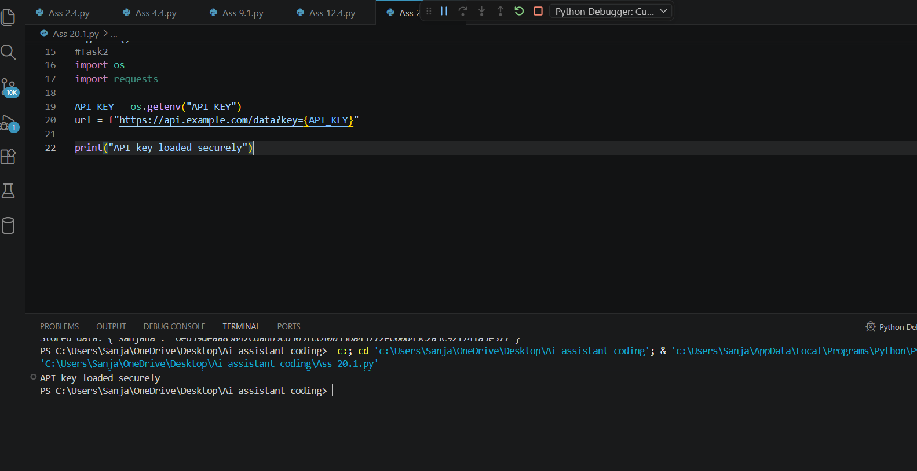
Observation:
The original script contained a hardcoded API key, which is a security vulnerability.
Hardcoded secrets can be exposed if the code is shared publicly.
The issue was fixed using environment variables with os.getenv().
This ensures secure and proper management of sensitive credentials.

#Task3:
Prompt:
Generate a Flask file upload example.
Check for unsafe file handling vulnerabilities.
Improve it using file type, size, and filename validation.
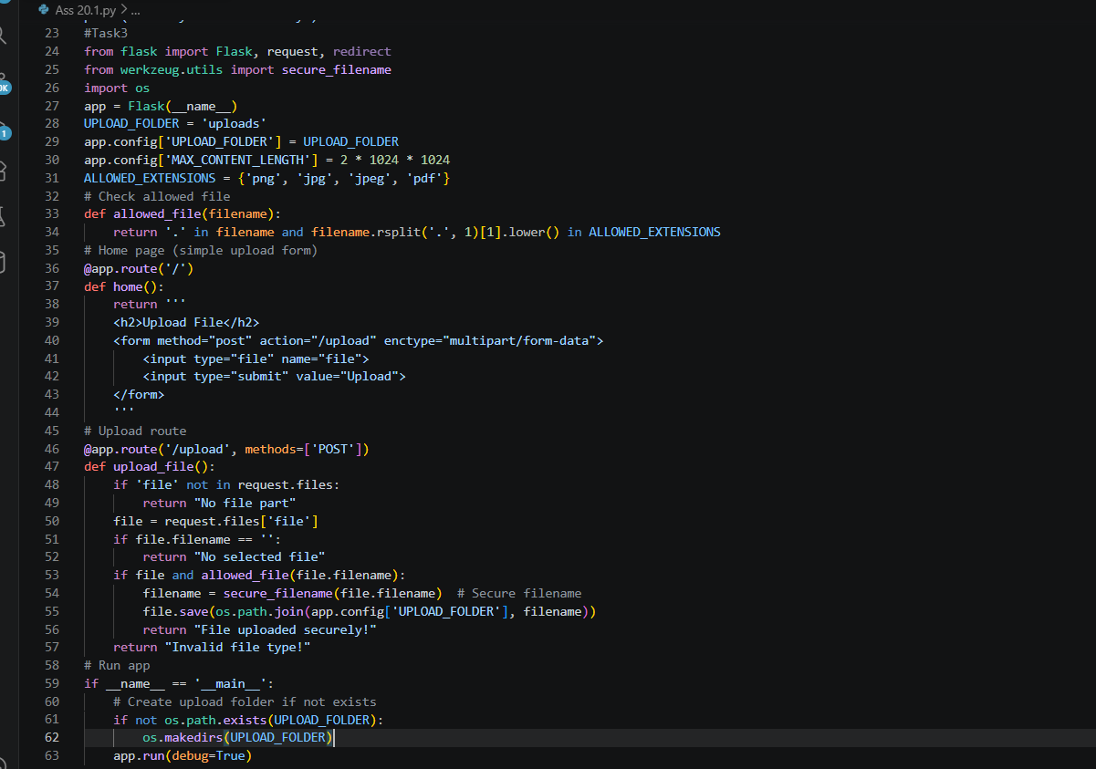
Output:
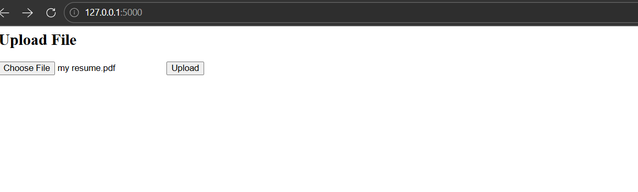
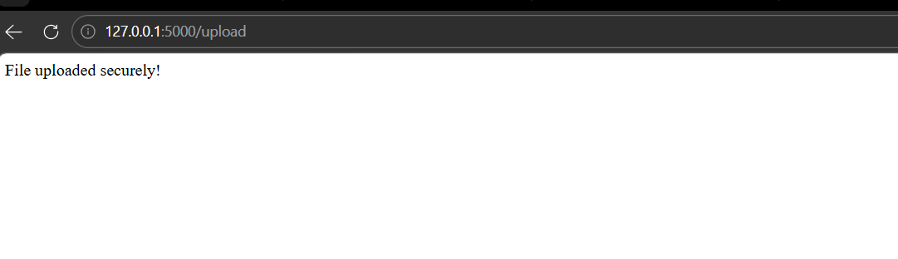
Observation:
The original file upload script was vulnerable to unsafe file handling.
Validation was added to allow only specific file types such as png, jpg, and pdf.
A file size limit and secure_filename() were used to prevent malicious uploads and unsafe filenames.
This ensures a secure file upload implementation resistant to common file-based attacks.
#Task4:
Prompt:
Generate a Python script that executes system commands using subprocess.
Check for command injection risks with user input.
Improve it using safe subprocess calls and input validation.
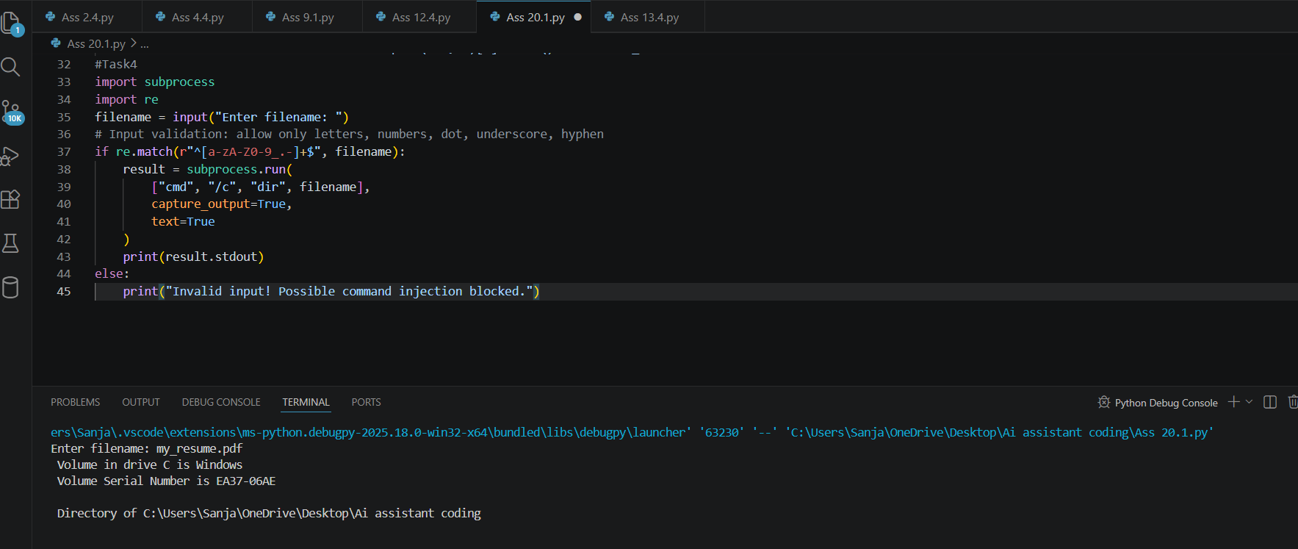
Observation:
The original script using os.system() was vulnerable to command injection through unsafe user input.
The issue was fixed by replacing it with subprocess.run() using a list of arguments.
Input validation was added using regular expressions to allow only safe characters.
This prevents execution of malicious commands and ensures secure command handling.
#Task5:
Prompt:
Generate an HTML and Flask feedback form.
Check for missing input validation and unsafe rendering.
Improve it using server-side validation and sanitization.
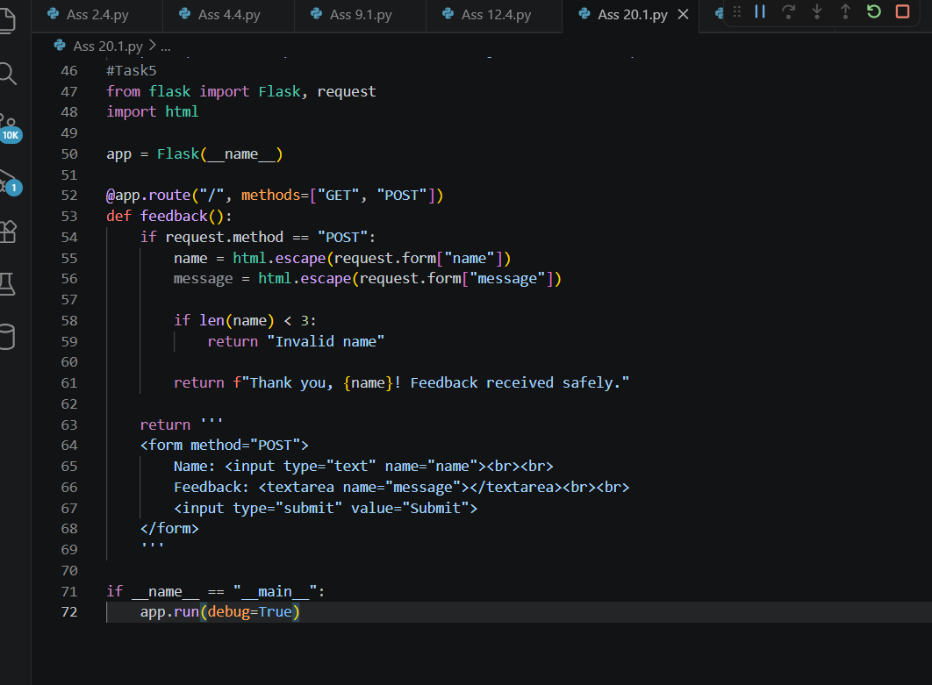
Output:
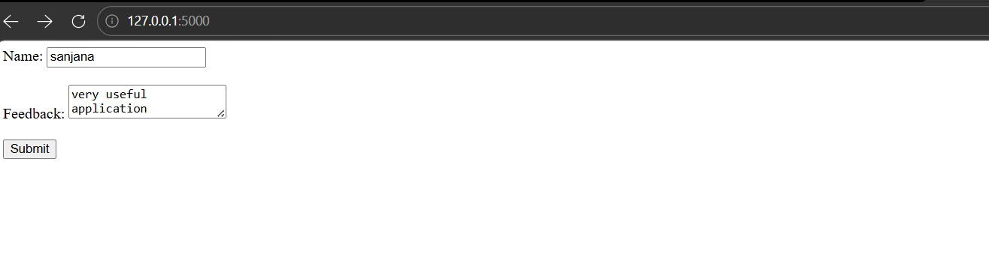
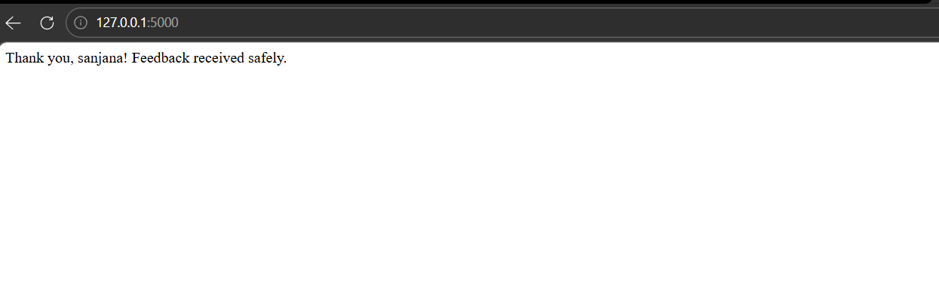Observation:
The original web form lacked proper server-side validation and sanitization.
This could lead to injection attacks such as XSS and unsafe rendering.
The issue was fixed using HTML escaping and input length validation.
This makes the form secure and resistant to malicious input attacks.

